26_Discover_ One Table with One Chart (Pivot Based)
Report Views
Standard View
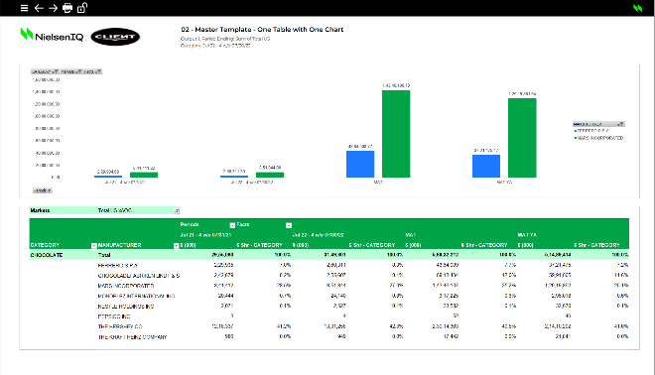

Standard View
Guidelines
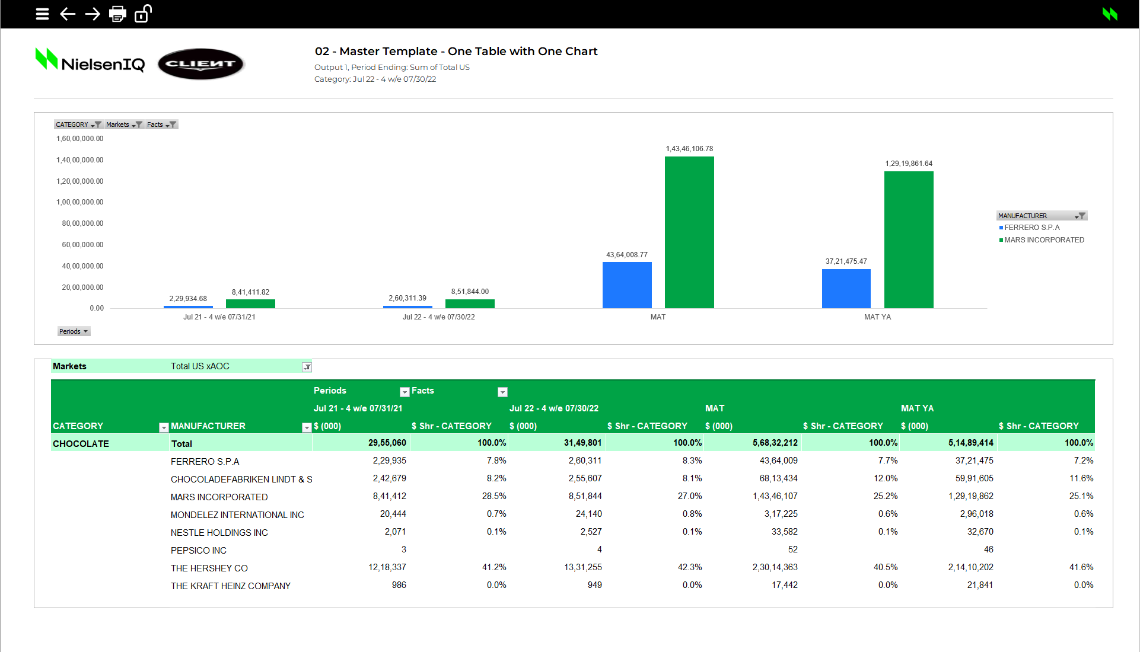
Template Name | 26_Discover_ One Table with One Chart (Pivot based)
View Name | Standard View
Methodology | Pivot Table + Pivot Chart
Default Dimension Order for Pivot Table | Filters | 1 Dimension | Markets
Default Dimension Order for Pivot Table | Columns | 2 Dimensions | Periods, Facts
Default Dimension Order for Pivot Table | Rows | 1 Dimension | Products (Characteristic 1, Characteristic 2)
Default Dimension Order for Pivot Table | Values | 1 Dimension | Values
Default Dimension Order for Pivot Chart | Filters | 3 Dimensions | Products (Characteristic 1), Markets, Facts
Default Dimension Order for Pivot Chart | Columns | 1 Dimension | Products (Characteristic 2)
Default Dimension Order for Pivot Chart | Rows | 1 Dimension | Periods
Default Dimension Order for Pivot Chart | Values | 1 Dimension | Values
Change dimension | - The dimensions can be swapped (in Developer Mode)  - Any dimension to be kept in Filters must be available in Rows in the Discover source input table  - The “*_Flag” field is to be used for sorting of a dimension, preferably Periods (trended). To do the same, please drag the “*_Flag” field to the area  (e.g. - Columns) for the Pivot table/chart above the field (e.g. - Periods) to be sorted. Then filter out the flag column using AZ column to exclude it from the pivot table view.  - *_Flag concept: If the first dimension in rows is Periods, then the label will be Periods_Flag. If it is facts, then the label will be Facts_Flag, and so on.
Data Selection Guidelines | Facts | - No limitation in number  - Can be renamed/re-labelled as per requirements  - Can be nested under another dimension (e.g. - Periods) in Pivot Table  - Multiple item/All selection in Filters is NOT recommended, as it will return erroneous aggregated values
Data Selection Guidelines | Products | - No limitation in number  - Can be renamed/re-labelled as per requirements  - Product selection starts with the Total product line followed by the products for the report
Data Selection Guidelines | Markets | - No limitation in number  - Can be nested under another dimension (e.g. - Periods) in the “Columns” area in Pivot Table
Data Selection Guidelines | Periods | - No limitation in number
Data Selection Guidelines | IMPORTANT:  - Pivot Fields will be locked in the auto-open mode and any changes in the same are to be done in the developer mode only.  - Poor performance can be observed mostly in reports with multiple Output Sheets.  - If any rows/columns are to be deleted, ensure you do not remove any important part of report configuration area.  - For the Pivot Chart, no dimension can be kept in Column area/section
To create a new report from this template | - Welcome Sheet – Check if the Configuration Area are filled in by the correct information.  - Output Sheet – Insert all the needed information on the first Row in the Parallel of the Table, if you add more Columns.  - Drag required fields/dimensions into respective areas for Pivot Table (follow Data Selection Guidelines above)  - Back end data selection/Pivot table for Pivot Chart is available from Row 550  - Drag required fields/dimensions into respective areas for Pivot Chart (follow Data Selection Guidelines above)  - Depending on the number of periods, the table formatting and Charts will have to be adjusted.  - To make formatting easier, the existing formats can be copied

